**Subhan Bin Yousaf**

**Section B**

**481281**

**FOP Lab Manual 4**

**Home Tasks**

**Home task 1 :**

#include <iostream>

using namespace std;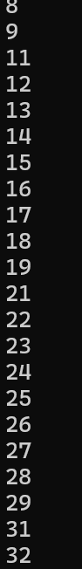

int main() {

int a = 0 ;

while (a<150) {

if(a % 10==0){

a++;

continue;

}

else{

cout<< a <<endl;

}

a++;

}

return 0;

}

**Home Task 2 :**

#include <iostream>

using namespace std;

int main(){

int a,b,c,sum ;

cout<<"Please enter the number you want the sum of "<<endl;

cin>>a;

b= a ;

while(a>0){

c=a%10;

sum+=c;

a=a/10;

}

cout<< sum <<endl;

return 0 ;

}

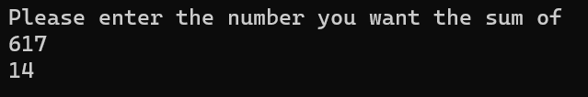

**Home Task 3 :**

#include <iostream>

using namespace std;

int main() {

int i,b;

cout<< " enter number " <<endl;

cin>>b;

for(i=2; i<b; i++){

if(b%i!=0 && b%3!=0){

cout<<"it is a prime number"<<endl;

break;

}

else {

cout<<"it is not a prime number"<<endl;

break;

}

}

return 0;

}

